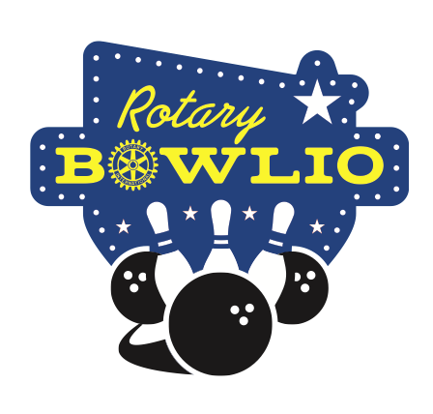**BOWLIO**

How Can I Participate?

Bowlio (the name is a contraction of Bowling to End Polio) began in 2011 and with a couple exceptions (the bowling alley closed in 2012 and the COVID pandemic in 2020) has continued until 2024 and BOWLIO X. All net proceeds go to The Rotary International’s PolioPlus Fund for the purpose of ridding the planet of this horrible disease once and for all. As of last year, donations to the Polio Plus funds have totaled nearly $40,000.

There are a number of ways to participate in BOWLIO:

* You can be a single player ($30). We take singles and we’ll find you a team. The cost includes three games and shoes are included.
* You can enter a team of up to four bowlers ($30 each). That also includes three games and shoes. And if you only have two friends – no problem – we always have singles looking for fun teams to play on.
* You can sponsor a lane ($100) and we will provide a banner that tells everyone of your sponsorship. You can sponsor a business or a favorite charity. For instance, there have been sponsors for Yuma Catholic High School, Yuma North End Rotary Club, Klein’s Electric . . . If you get in early enough you will be included in our promotional material as a Bowlio Sponsorship Partner.
* Or, you can sponsor a lane and enter a team and we will knock twenty bucks off the total cost ($200).

There will be other surprises as well that promise to make this as fun as possible. And all for a great cause. Why wouldn’t you participate?